FitHub AI — Project Documentation

1. Overview
FitHub AI is an AI-powered fitness coaching web application with the tagline “Train smarter. Live better.” It creates personalized workout routines, tracks progress, and helps users stay consistent with smart fitness coaching built around their goals. The app has a marketing-style home page, a dashboard, an interactive workout planner, and a contact page, and is deployed to a live server accessible over HTTP.

2. Tech Stack
Layer | Technology
Backend Framework | FastAPI (Python)
Templating | Jinja2 (base.html, home.html, dashboard.html, planner.html, contact.html, index.html)
ORM / Database | SQLAlchemy + SQLite (fitbuddy.db)
AI Provider | Google Gemini API — gemini-2.5-flash used for both workout generation and tips
Server | Uvicorn (ASGI)
Config Management | .env file (APP_NAME, DATABASE_URL, GOOGLE_API_KEY, model names, ADMIN_TOKEN)
Deployment | Dockerfile + Procfile + render.yaml, plus a deploy_vps.sh script for VPS deployment
Frontend | HTML/Jinja2 templates with a dark, gradient-accented UI

3. Pages & Core Features
Navigation: Home | Dashboard | Workout Planner | Contact
- Home page — hero section (“Train smarter. Live better.”) with a call to action (Start free / View dashboard) and a live stats widget showing a progress ring (e.g. 74%), step count, active minutes, and a fitness score, plus a “Why people choose FitHub” section.
- Dashboard — user/coach view of progress and stored plans.
- Workout Planner — a multi-field form that collects: Goal (e.g. Lose fat), Available time per session, Experience level, Training style, Days per week, Equipment available, Body focus, Recovery status, Height, Weight, Target weight, BMI goal, and Preferred training days.
- AI-Generated Workout Output — after clicking “Generate plan,” the app displays an AI-generated card with estimated calories burned, focus area, and level, followed by a categorized exercise breakdown (Warm-up, Cardio, Leg, Upper body, etc.) with reps or duration per exercise.
- Contact page for user inquiries.
- Admin/config controls via an ADMIN_TOKEN environment variable.

4. Project Structure
fitbuddy-ai.nit/
├── app/
│ ├── __init__.py
│ ├── config.py # Loads settings from .env
│ ├── main.py # FastAPI app entry point
│ ├── routes.py # Route handlers for all pages
│ └── template/
│ ├── base.html
│ ├── home.html
│ ├── dashboard.html
│ ├── planner.html
│ ├── contact.html
│ └── index.html
├── venv/
├── .env / .env.example
├── .dockerignore
├── Dockerfile
├── Procfile
├── render.yaml
├── deploy_vps.sh # VPS deployment script (git pull, venv setup, writes .env)
├── start.ps1
├── requirements.txt
└── runtime.txt

5. Configuration (.env)
APP_NAME=FitHub AI
DATABASE_URL=sqlite:///./fitbuddy.db
GOOGLE_API_KEY=
GEMINI_WORKOUT_MODEL=gemini-2.5-flash
GEMINI_TIP_MODEL=gemini-2.5-flash
ADMIN_TOKEN=fitbuddy-admin

6. Deployment
The deploy_vps.sh script automates deployment to a VPS:
- Clones the repo into the app directory if not already present (git clone $GIT_REPO).
- Creates a Python virtual environment and installs dependencies from requirements.txt.
- Writes the .env file with app name, database URL, Gemini API key/model settings, and admin token.
- A Dockerfile, Procfile, and render.yaml are also included, so the app can alternatively be deployed as a container or on a platform like Render.
The app is currently verified running locally at http://127.0.0.1:8012 (confirmed via a live HTTP check returning 200 OK).

7. Setup & Installation (Local)
Windows (PowerShell):
python3 -m venv .venv
. .venv\Scripts\Activate.ps1
pip install --upgrade pip
pip install -r requirements.txt
# create .env with the variables listed in section 5
uvicorn app.main:app --reload
Once running, open the app in your browser at the configured host/port (e.g. http://127.0.0.1:8012).

8. Screenshots
VS Code — Project & Deployment Script
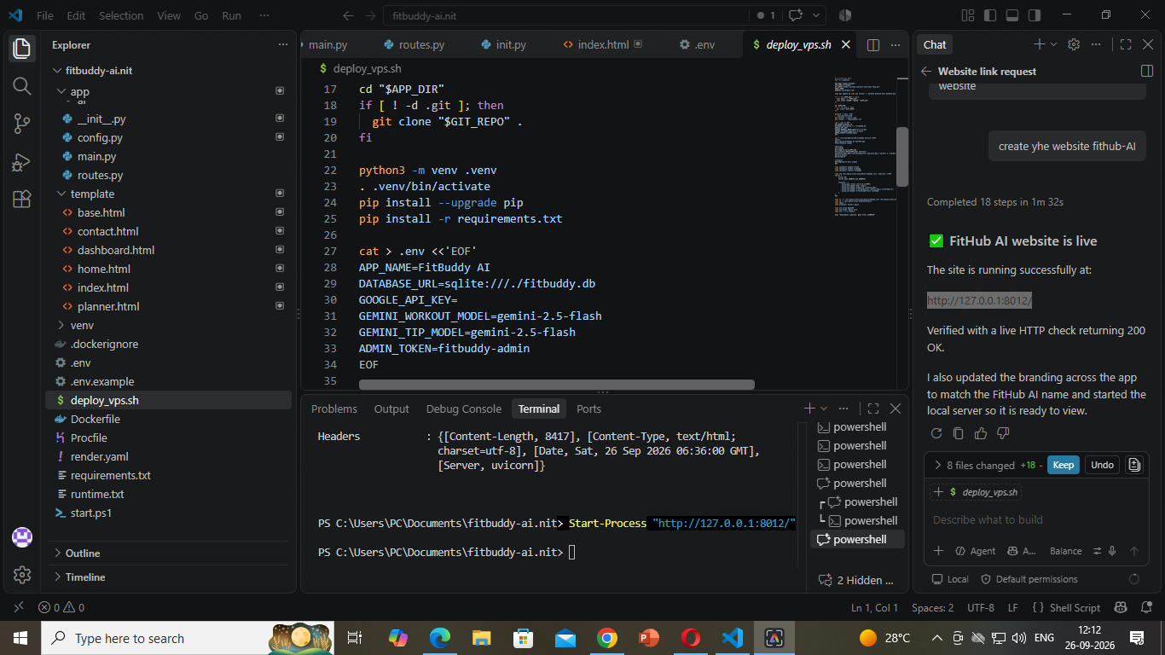
Figure 1: Project structure in VS Code and deploy_vps.sh, with a live HTTP 200 check confirming the site is running at http://127.0.0.1:8012.
Home Page
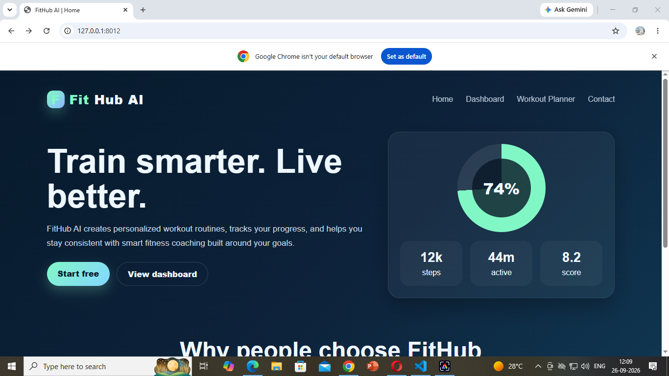
Figure 2: FitHub AI home page — hero section, live stats widget, and navigation.
Workout Planner
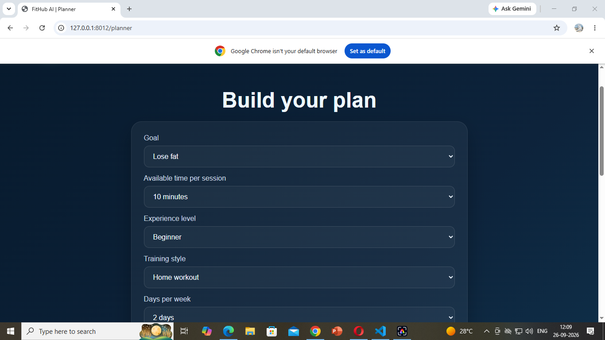
Figure 3: Workout Planner form — Goal, session time, experience level, training style, days per week.
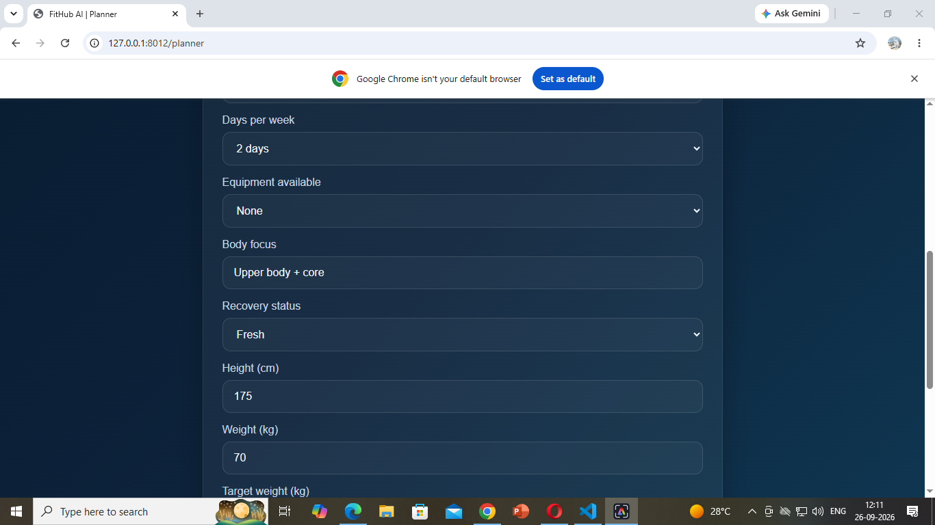
Figure 4: Workout Planner form (continued) — equipment, body focus, recovery status, height/weight.
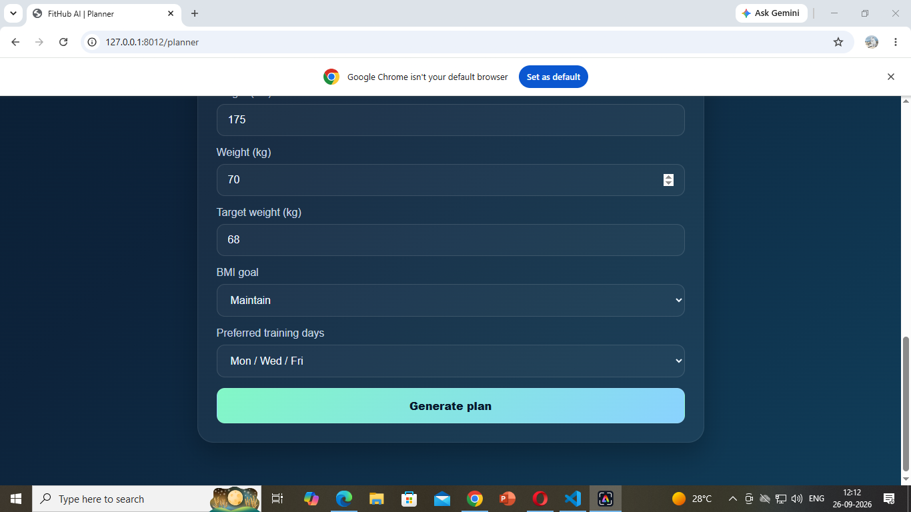
Figure 5: Workout Planner form (continued) — target weight, BMI goal, preferred training days, and Generate plan button.
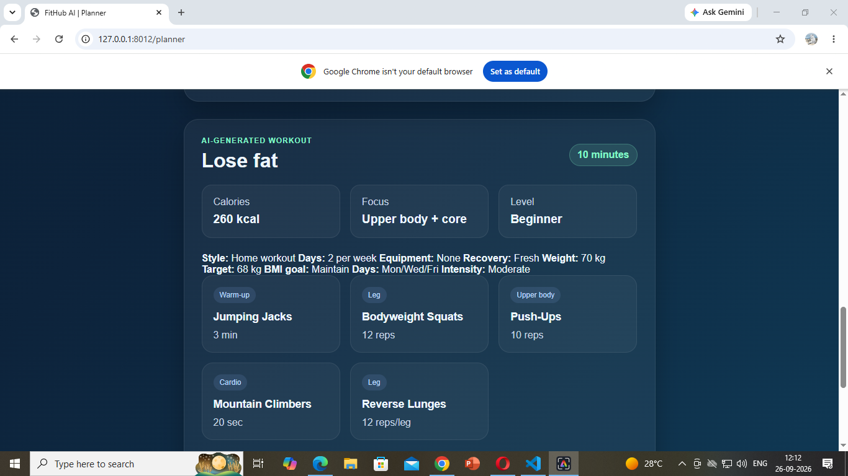
Figure 6: AI-generated workout output — calories, focus, level, and categorized exercises.

9. Known Limitations / Notes
- Fitness and nutrition content generated by the app is general information only and is not a substitute for professional medical or dietary advice.
- Admin/config access is protected only by a static ADMIN_TOKEN value — consider stronger authentication before any public deployment.
- Verify GOOGLE_API_KEY is set in production; otherwise AI-dependent features may fail or need a fallback mode.

10. Future Enhancements (Suggested)
- Add user authentication/login for the dashboard.
- Persist and visualize historical progress (steps, active minutes, score trends).
- Add automated tests for the planner form and AI output generation.
- Set up HTTPS and a custom domain for the production deployment.

